Press Release
12th August 2021
Press Contact:
Paul Barnes | +44 (0)7837 917 611 | paul.barnes@icomera.com

Passenger Accessibility: GoMedia’s ‘First of a Kind’ Digital Innovations Win DfT Funding

GoMedia, a subsidiary of Icomera and of EQUANS, the newly created leader in multi-technical services, is supporting three pioneering digital solutions to improve rail transport accessibility for the visually and hearing-impaired. The projects are funded by the Department for Transport through the £9m First of a Kind 2021 (FOAK21) competition, delivered by Innovate UK (part of UKRI), aimed at making the UK's rail network greener, cleaner, and more accessible through innovation.

With a significant number of competitive applications for the funding, GoMedia has once again demonstrated its trusted capability to deliver leading accessibility and digital solutions to the rail industry, leading two projects and providing significant support to a third, out of only 30 high profile projects awarded.

Personal onboard announcements to facilitate the journeys of hearing-impaired users

The first initiative, Hearing Enhanced Audio Relay (HEAR) aims to improve accessibility for hearing-impaired passengers on trains, through personal onboard announcements. This solution is widely supported by the UK’s train operators. When connected to the onboard Wi-Fi, these notifications can be heard or read via an app installed on users’ personal devices, keeping them updated with the journey information they need, in a format that they need. Project HEAR is set to begin live trials on Transport for Wales services in Q1 2022.

Providing visually-impaired passengers with stress-free ways to get to their platform

Visually Impaired Navigation (VIN) improves accessibility in busy station environments for partially-sighted and blind passengers by using technology powered by GoMedia’s real-time information capabilities. The application is developed in collaboration with the Royal National Institute of Blind People (RNIB) and makes use of NaviLens BIDI codes. Passengers can use their personal device to scan the specially designed NaviLens tag to get to the right platform in the most optimal, stress-free way. Project VIN’s test phase is set to take place from December 2021 to February 2022 on a Network Rail managed station.
Leveraging technology to bring fast and reliable help anywhere in the station

GoMedia are also collaborating with augmented reality (AR) provider Skignz from November 2021. The project will leverage AR technology to provide live journey information, platform navigation, and the ability for staff and passengers to locate each other when assistance is needed, all by viewing intelligently placed in-app AR markers overlaid on their smart device’s screen.

Roger Matthews, GoMedia’s Managing Director, said: "GoMedia is excited to further demonstrate its leadership in multilingual digital accessibility solutions through its contributions to FOAK2021. More than 60% of passengers with accessibility needs do not attempt or struggle to make independent journeys on public transport. Addressing this accessibility issue will not only improve passenger satisfaction, it can also reduce the estimated impact of sight loss on the UK economy that runs into tens of billions of pounds per year.”

Peter Kingsland, Icomera's Senior Vice President for the UK, added: "Improving passenger accessibility on public transport is vital to the UK Government and the rail industry, as exemplified by FOAK2021. GoMedia’s work in improving the digital passenger experience through innovation is a perfect extension of Icomera’s mission to make public transport a more attractive option than other, less sustainable means of transport.”

“EQUANS’ purpose is to power, protect and connect people. Through GoMedia’s projects, we are pleased to carry out this mission and provide our clients with solutions tailored to each of their customers’ needs. Ensuring easy and safe access to public transportation for all is essential and digital solutions, which allow for personalised and at hand support for each customer, help make that happen”, concludes Pierre Hardouin, Managing Director of EQUANS France.

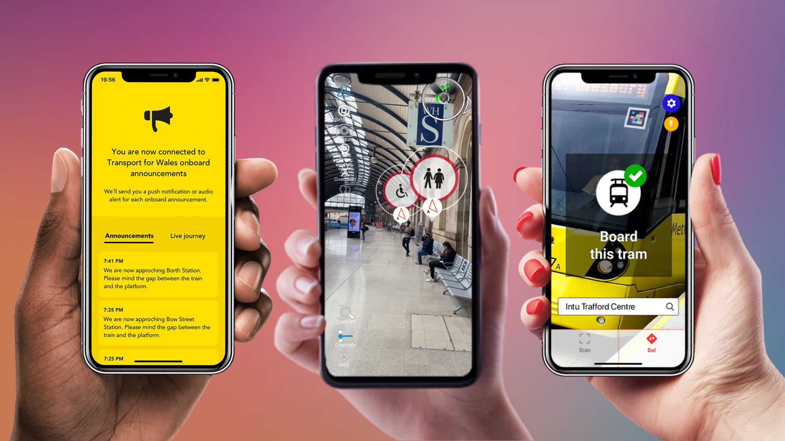

Image: GoMedia supports a range of digital solutions aimed at improving passenger accessibility.
(View Full Resolution)

About GoMedia

GoMedia creates award-winning infotainment platforms for rail, coach and transport companies, including Avanti West Coast, Greyhound Buses (USA), TransPennine Express, SBB (Switzerland), Capitol Corridor (California) and more. In September 2020 GoMedia was acquired by Icomera, a subsidiary of EQUANS and the world’s leading provider of integrated connectivity solutions for public transport. GoMedia is helping to deliver The Connected Journey, improving the onboard experience through world leading entertainment, live passenger information, and a range of messaging solutions delivered to passengers’ own mobile devices. For more information, visit gomedia.io

About Icomera
Icomera is the world’s leading provider of integrated connectivity solutions for trains, trams, buses and coaches, serving millions of passengers and tens of thousands of onboard systems on a daily basis. We deliver the fastest, most reliable and secure Internet connection available to a moving vehicle, supporting a wide range of digital applications which increase passenger satisfaction, enhance operational efficiency, and improve safety and security. Our solutions make transport more attractive for passengers and part of a smarter, safer, greener future for everyone, accelerating the transition towards a carbon-neutral world.
A wholly owned subsidiary of EQUANS, Icomera is headquartered in Gothenburg, Sweden, with main offices in the United Kingdom, France, Germany, Italy, the United States, and Canada. Find out more at icomera.com

About EQUANS

EQUANS is the world leader in multi-technical services, with 74,000 employees in 17 country hubs and an annual turnover of over 12 billion euros.
EQUANS designs, installs and provides customised solutions to improve the technical equipment, systems and processes of its clients and to optimise their use through their energy, industrial and digital transitions. Thanks to a strong territorial footprint through historical local brands and excellent technical know-how in their clients’ businesses, EQUANS' highly-qualified experts are able to support territories, cities, industries, and buildings in HVAC (heating, ventilation and air conditioning), Cooling and Fire protection, Facility Management, Digital & ICT, Electrical, Mechanical & Robotics.
EQUANS is the number one company on the main European markets (France, Belgium, the Netherlands and the UK) and is also well ranked in the US and in Latin America. EQUANS is a separate entity of ENGIE.

About ENGIE

We are a leading world group that provides low-carbon energy and services. With our 170,000 employees, our clients, our partners and our stakeholders, we strive every day to act to accelerate the transition towards a carbon-neutral economy, through reduced energy consumption and more environmentally friendly solutions. Guided by our purpose statement, we reconcile economic performance with a positive impact on people and the planet, using our expertise in our key business areas (gas, renewable energies, services) to provide competitive solutions to our clients. Turnover in 2020: 55.8 billion Euros. Listed on the Paris and Brussels stock exchanges (ENGI), the Group is represented in the main financial indices (CAC 40, DJ Euro Stoxx 50, Euronext 100, FTSE Eurotop 100, MSCI Europe) and extra-financial indices (DJSI World, DJSI Europe, Euronext Vigeo Eiris - Eurozone 120 / Europe 120 / France 20, MSCI EMU ESG, MSCI Europe ESG, Euro Stoxx 50 ESG, Stoxx Europe 600 ESG, and Stoxx Global 1800 ESG).

